**XClarity Administration:**

Login to XClarity web Site

<https://delinvmva500/>

or

<https://10.1.20.168>

User Name: xAdmin

Password: <see password safe>

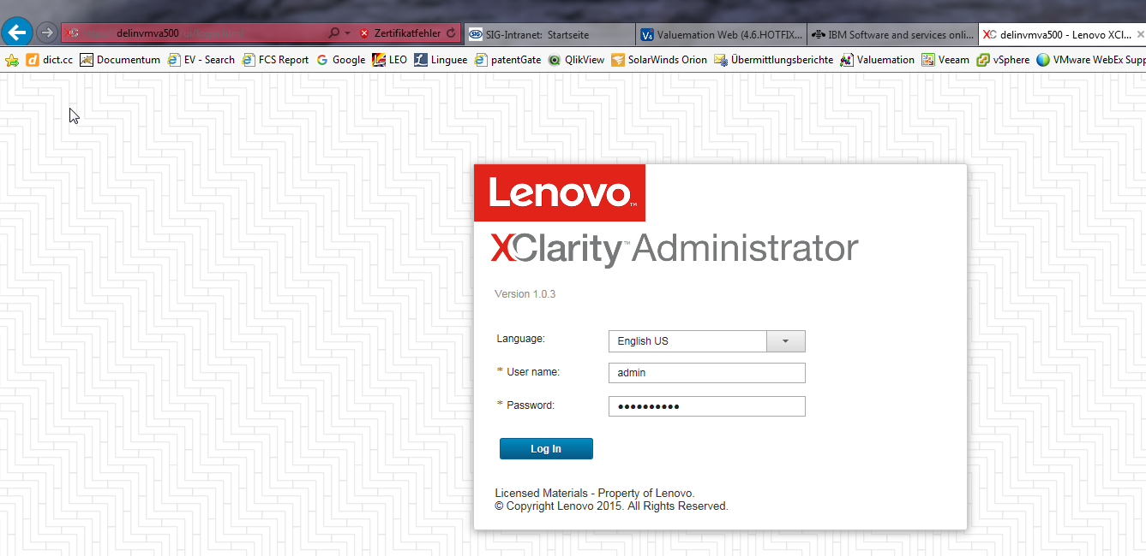

To add a new server to Lenovo XClarity Administrator go to

Hardware=>Discover an Manage New Devices

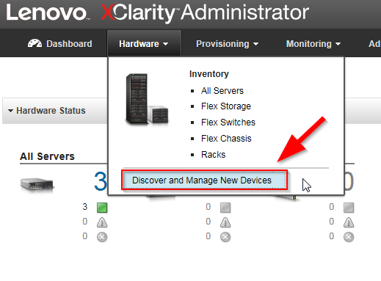

Now you will see all unmanaged servers which are compatible with XClarity

Check the server and press “Manage Selected”

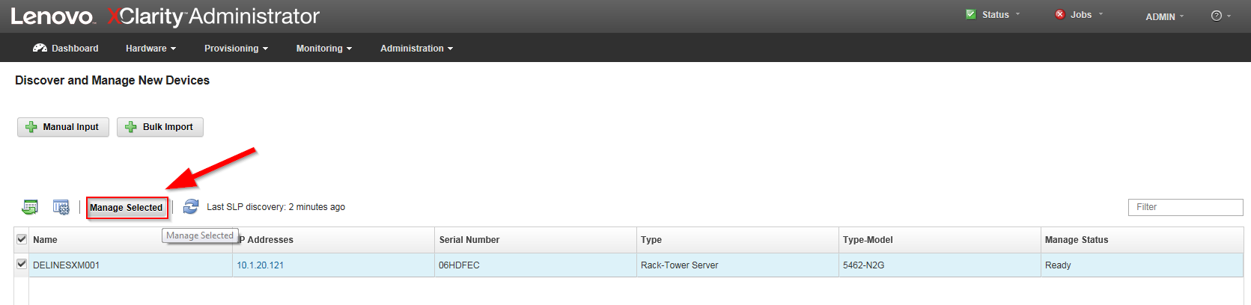

Now enter the IMM credentials of the destination server

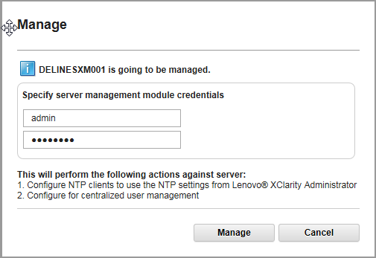

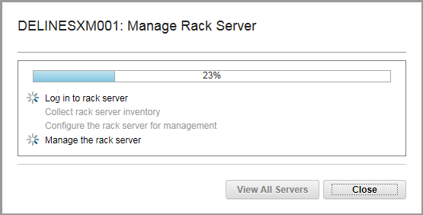

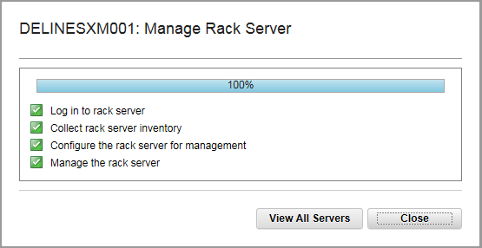

Now you will see the new server with the status “Pending” for some minutes

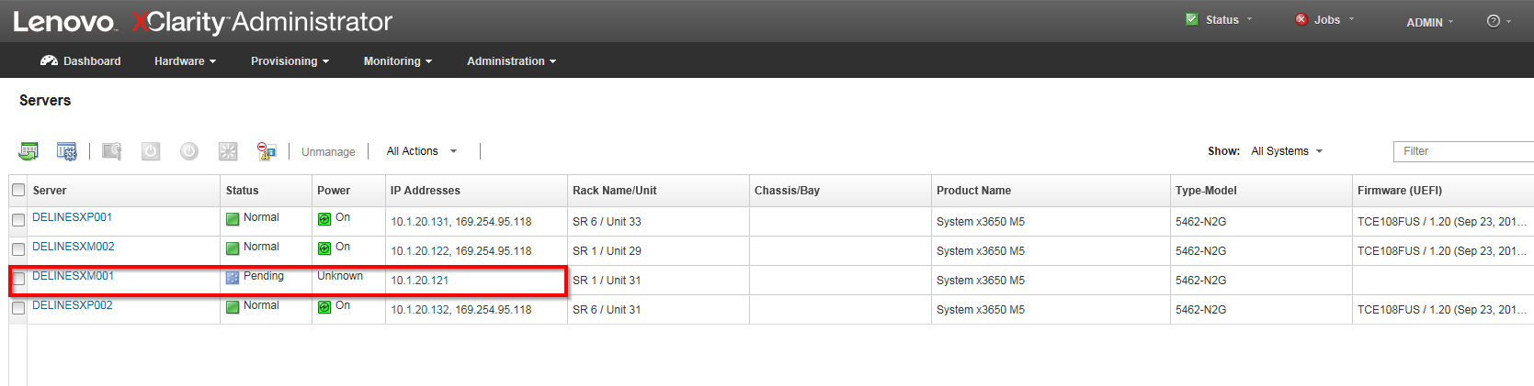

and finally it will look like this.

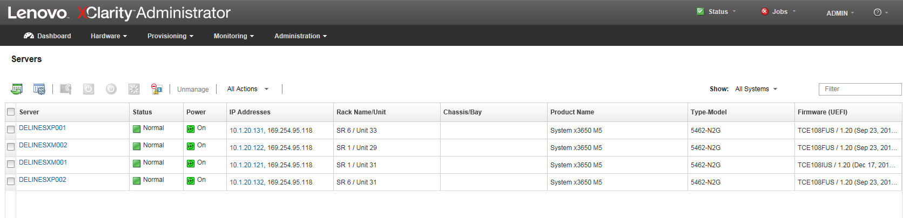

You can also create racks to group the hardware in different locations for example two data center

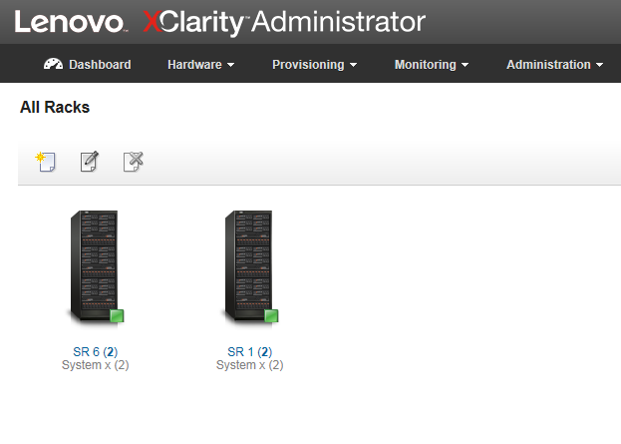

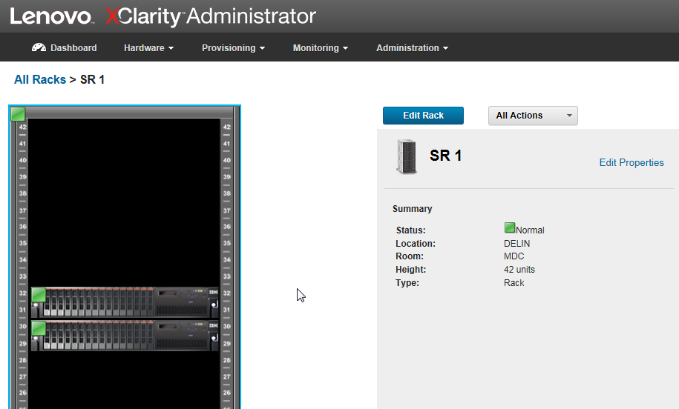

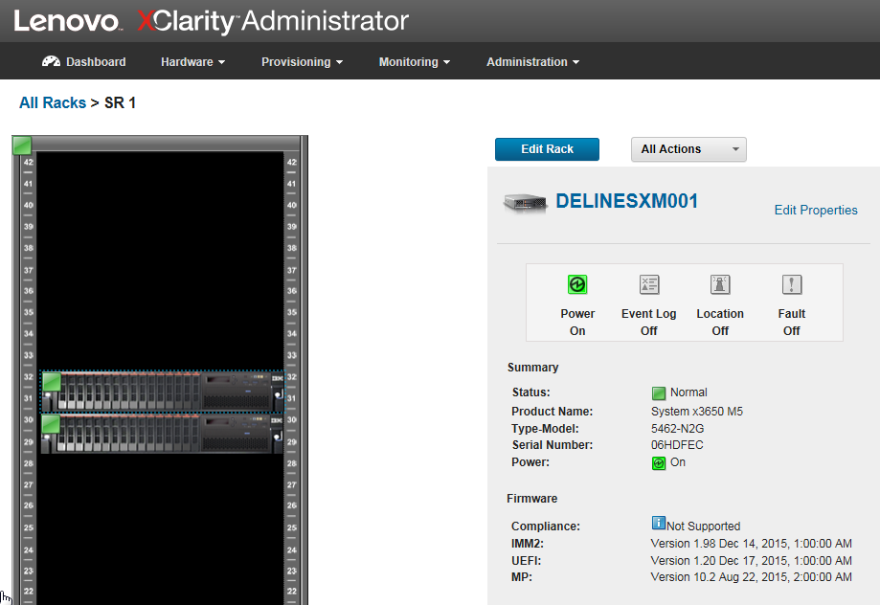

**Firmware Updates: Compliance Policies**

You can create a firmware update policy

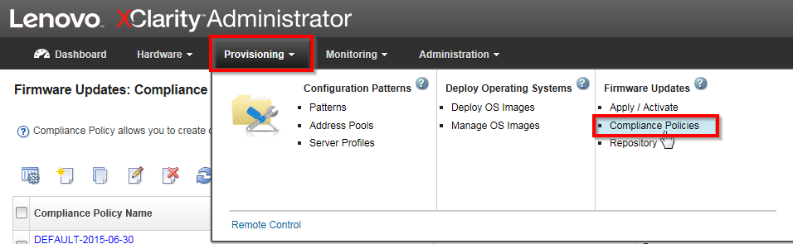

Then click create

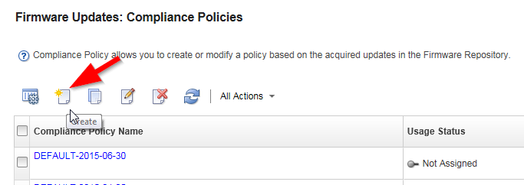

Now enter a name and select your system

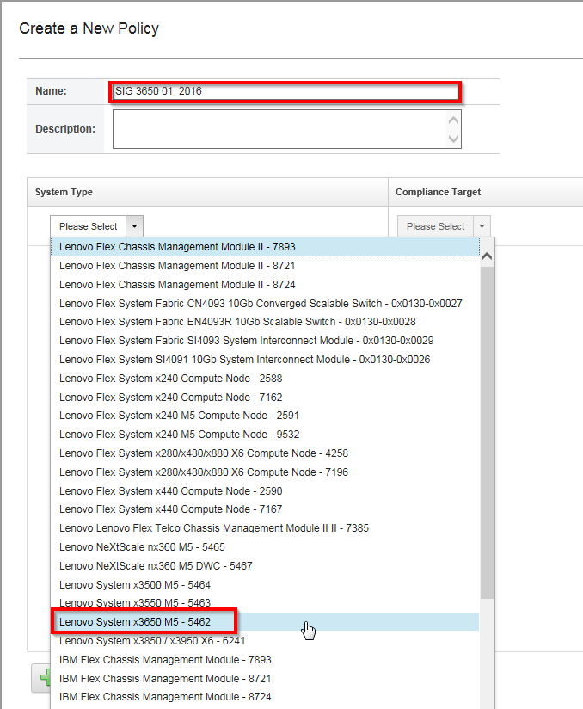

Now select your “Compliance Target” and press “Create”

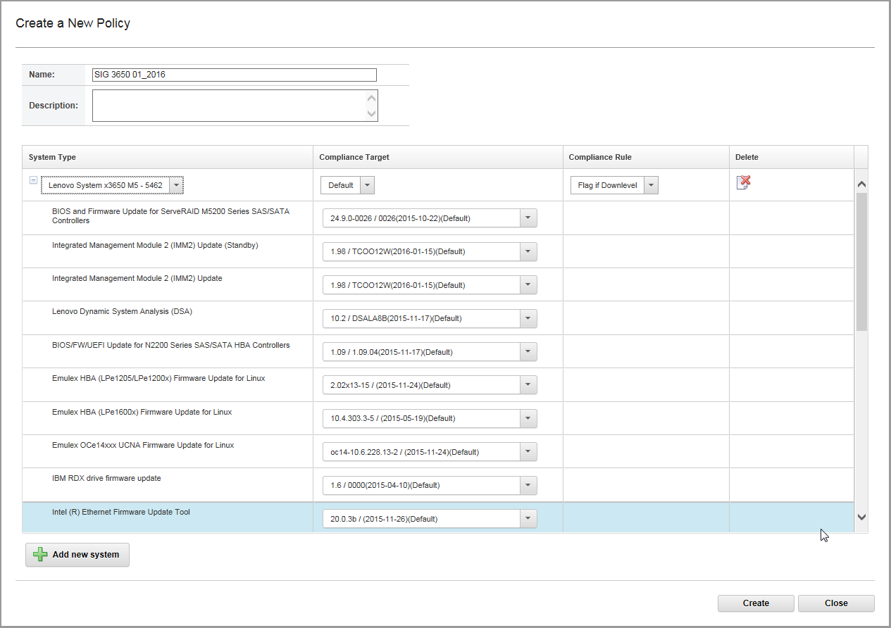

In the next step select Provisioning => “Apply / Acticate”

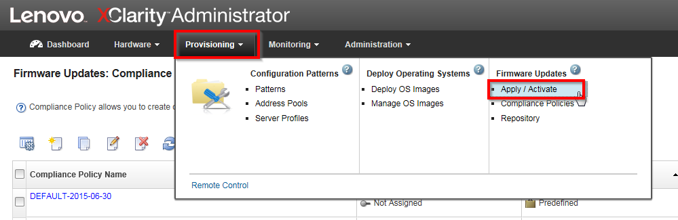

Select the new added server and the policy

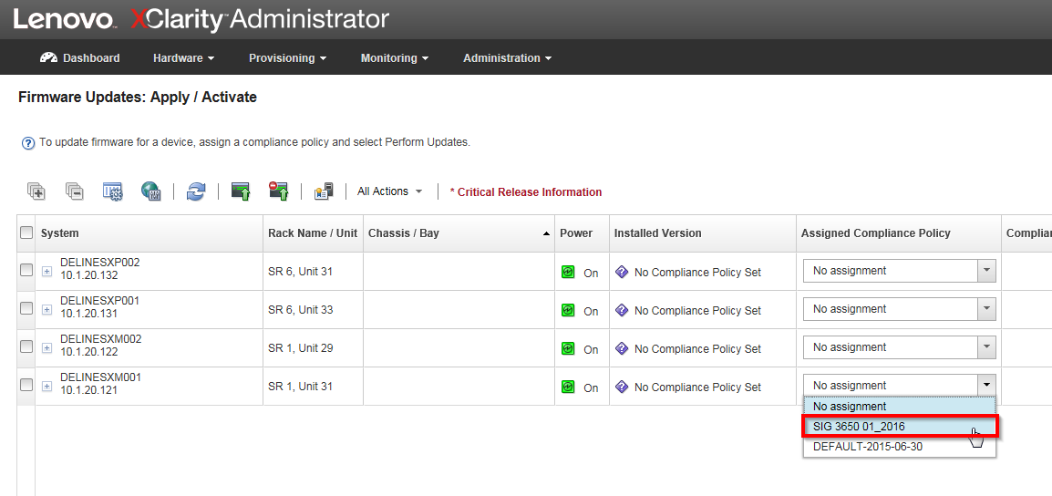

Now select the server and perform the update

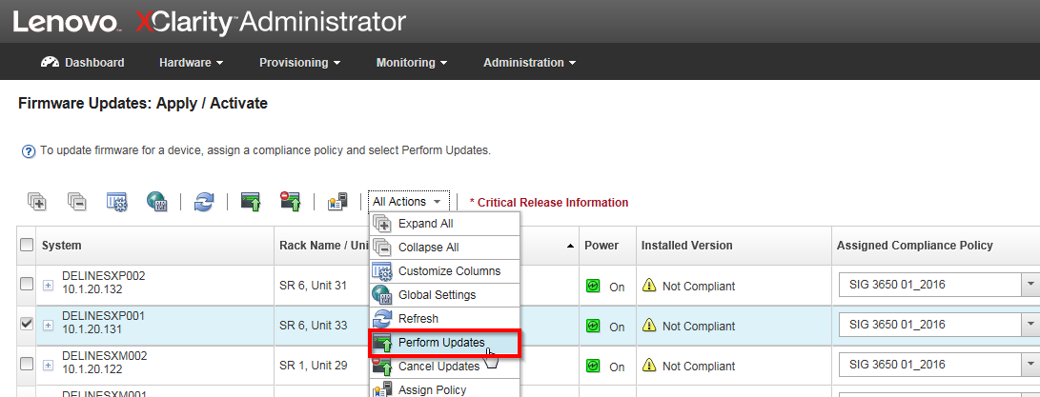

After the update is uploaded the server should be compliant

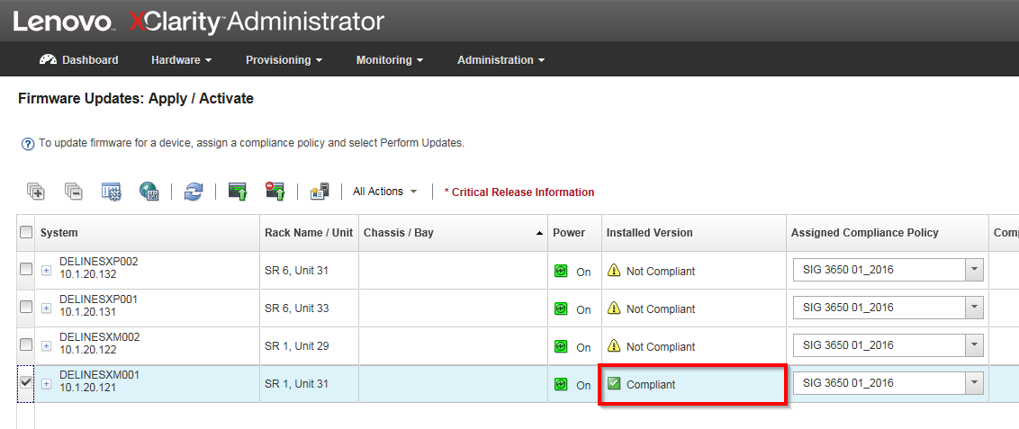

**Update Management Server**

For updating the management server do the following

First check if you have internet access (Proxy settings)

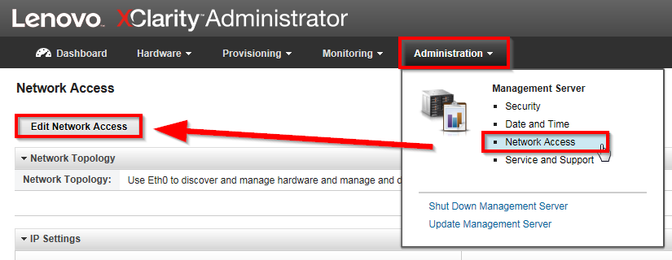

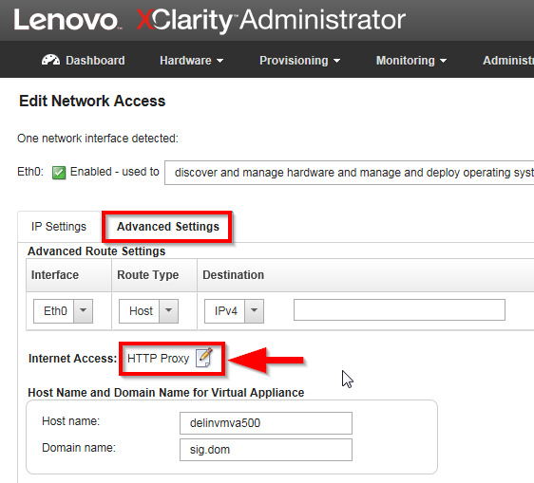

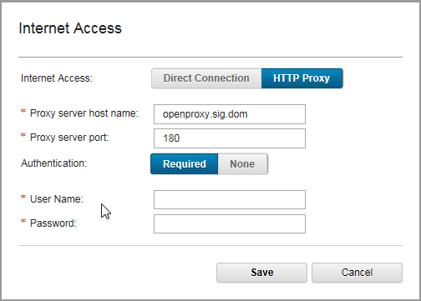

To update the server go to Administartion => “Update Management Server”

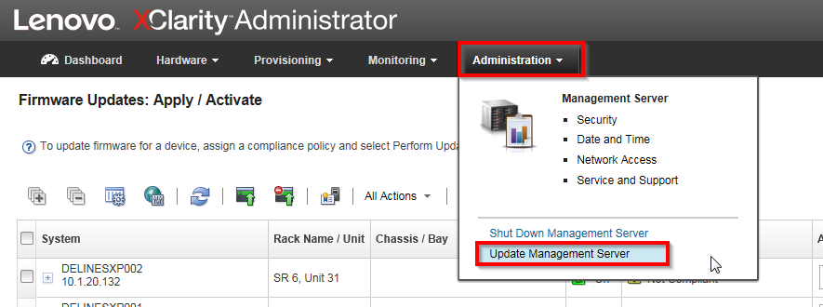

First refresh the repository to the latest level

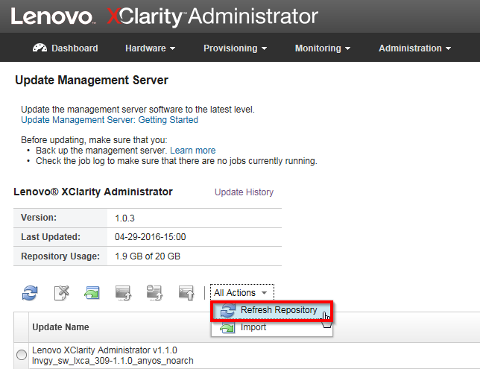

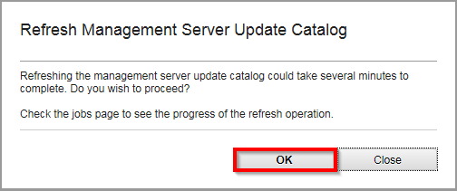

This can take several minutes.

You can check the status here:

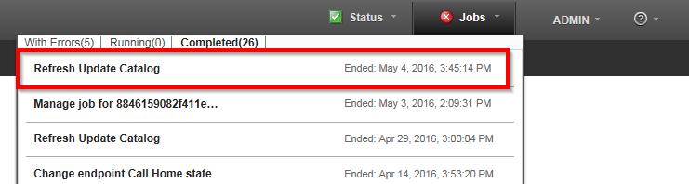

Finally you have a catalog and can select what you want to update

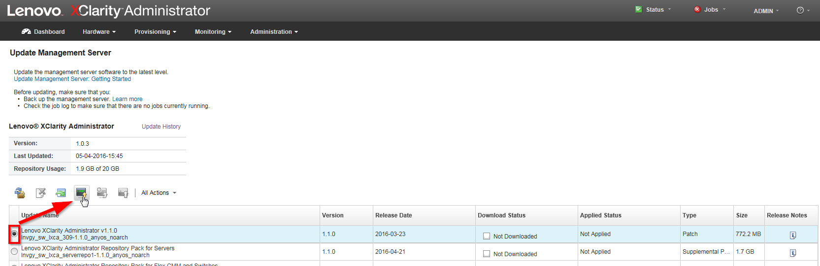

Download the patch



After successful download you have to apply the patch

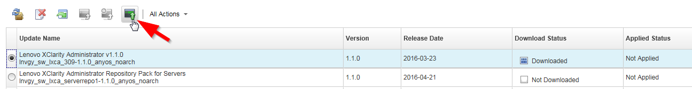

If you want you can take a look at the console to see the update process

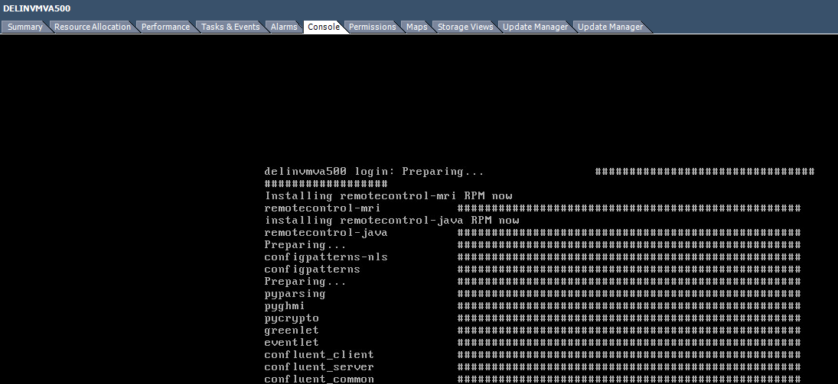

After successful update you will see an “Applied Status”

